* Created Jupyter Nootebook for Model
* Refactorization of Notebook to python script
* Created Docker File

1. Inside of Notebook

import Lıbraries section

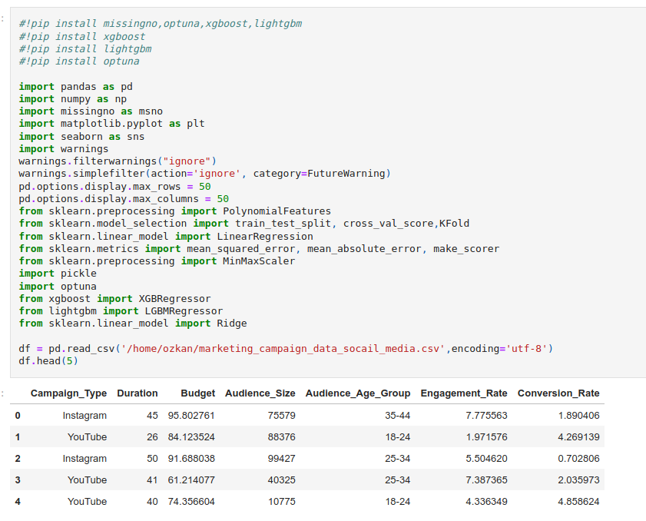

Mıssıng Value Section

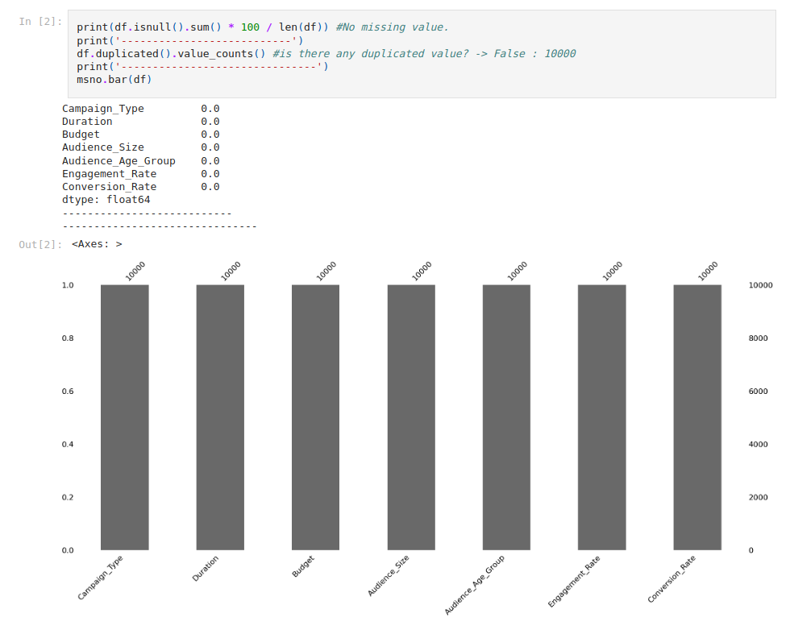

First Looks of data and values

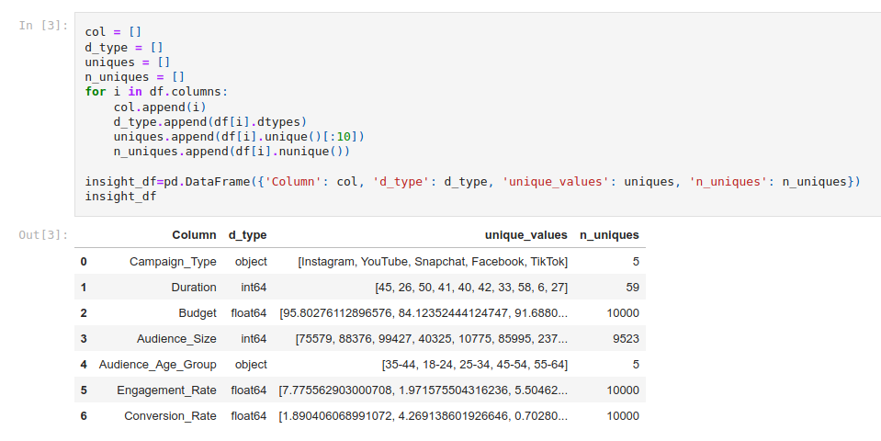

Data Analysis Section

First graph is Campaign_Type hue with Audience_Age_Group

Second graph is Audience_Size hue with Campaign_Type

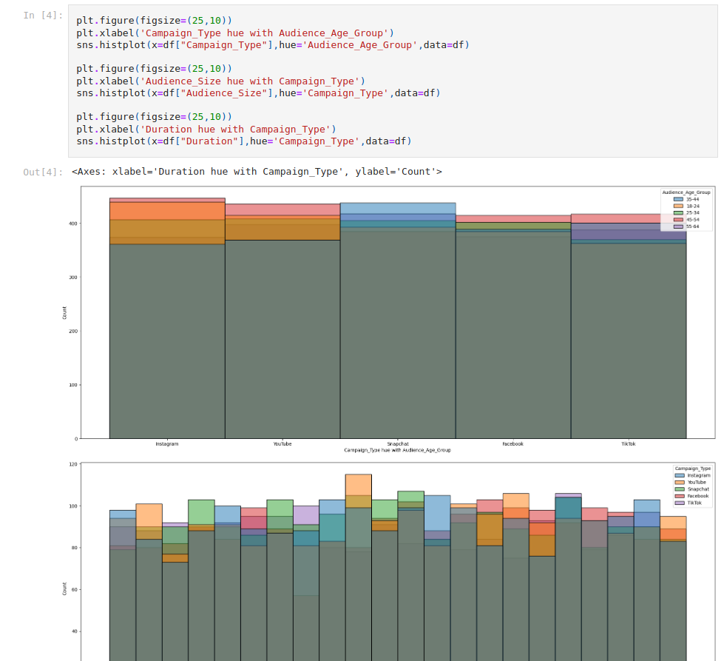

Duration hue with Campaign Type

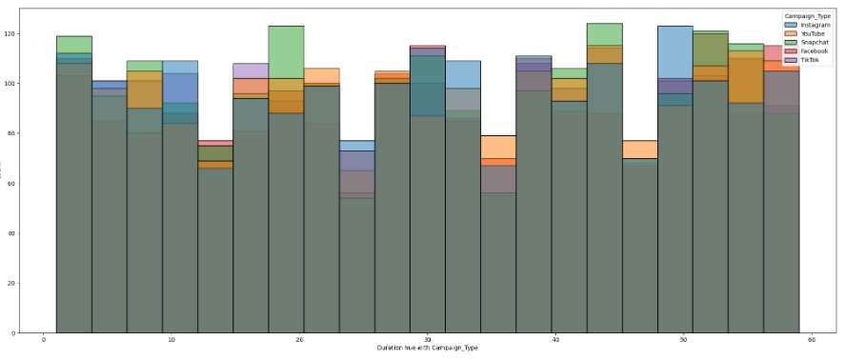

Heatmap of Data

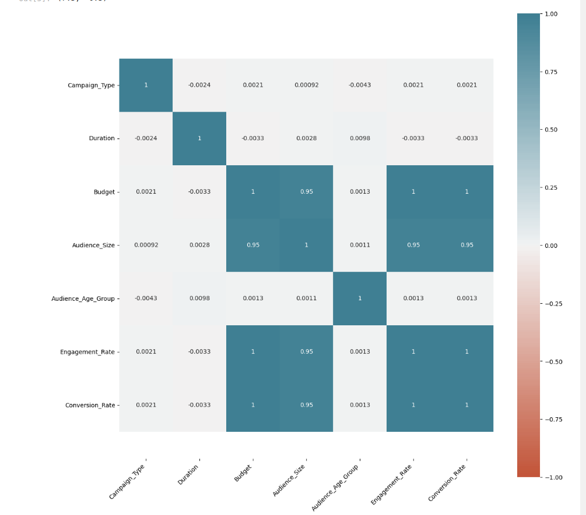

Feature Engineering Section

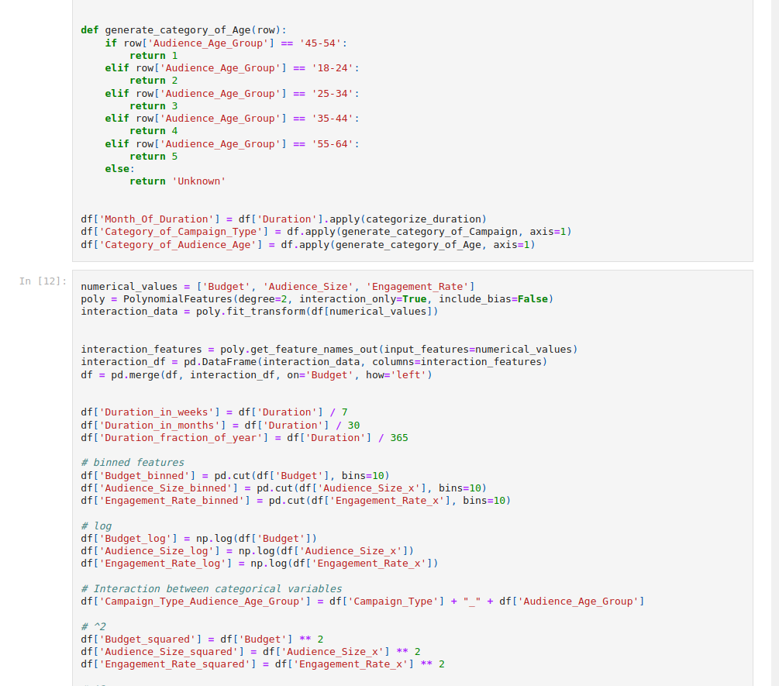

Model Section Basic LinearRegression

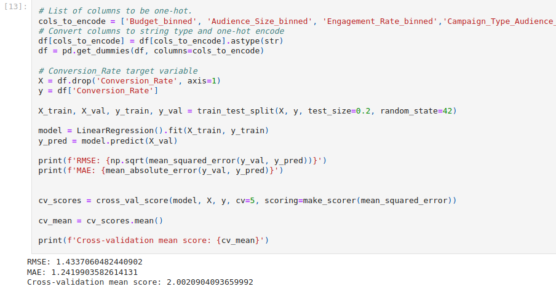

Error Analysis and Model Feature Importance

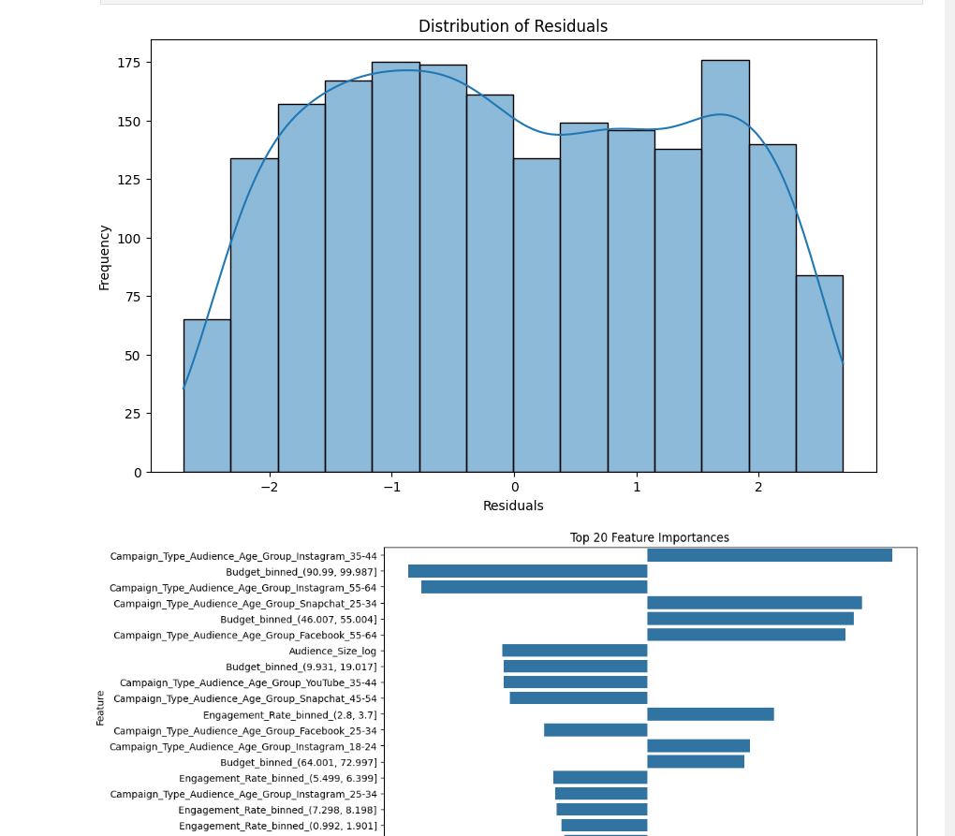

More models & Experiments : Xgboost and LıghtGBM

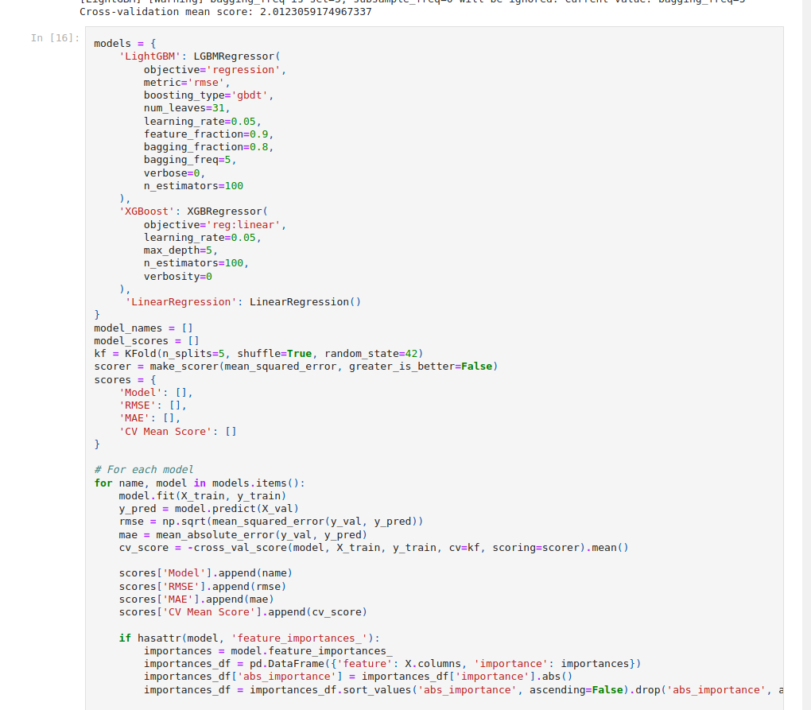

Feature Importance

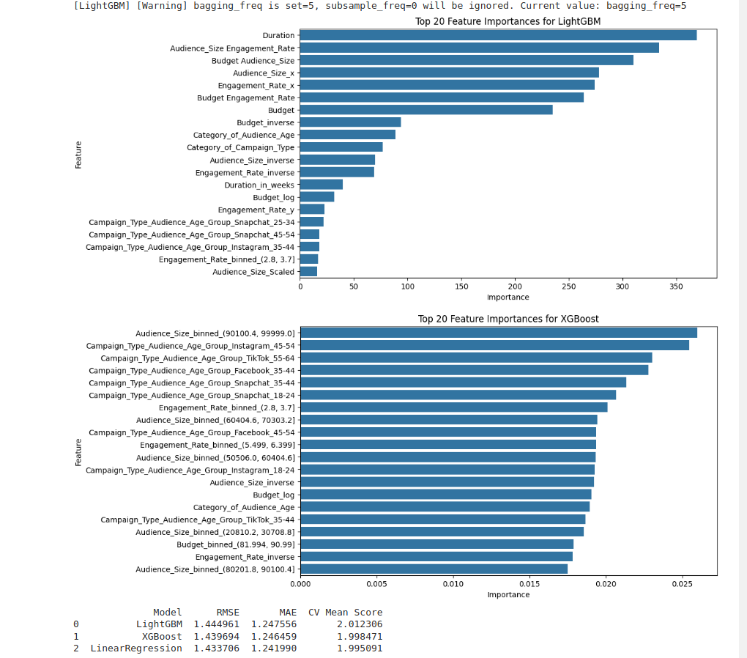

Hyperparameter Tuning Section

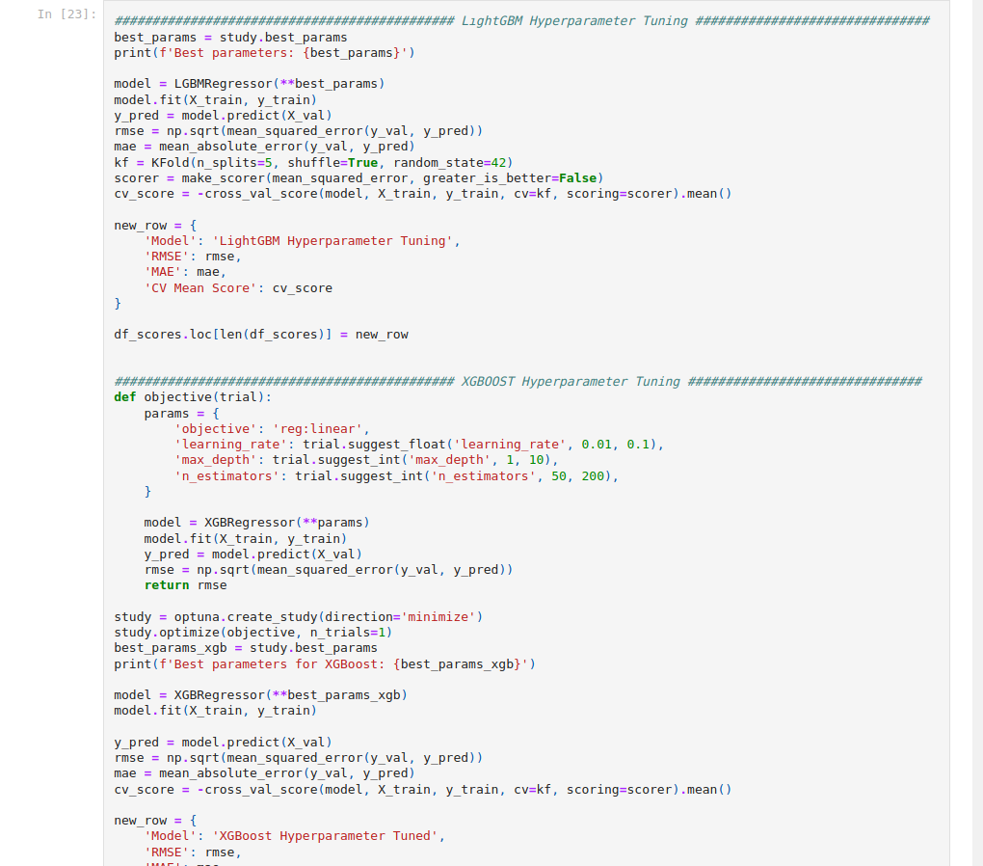

Models & Hyperparameter Models & Pıckle Models

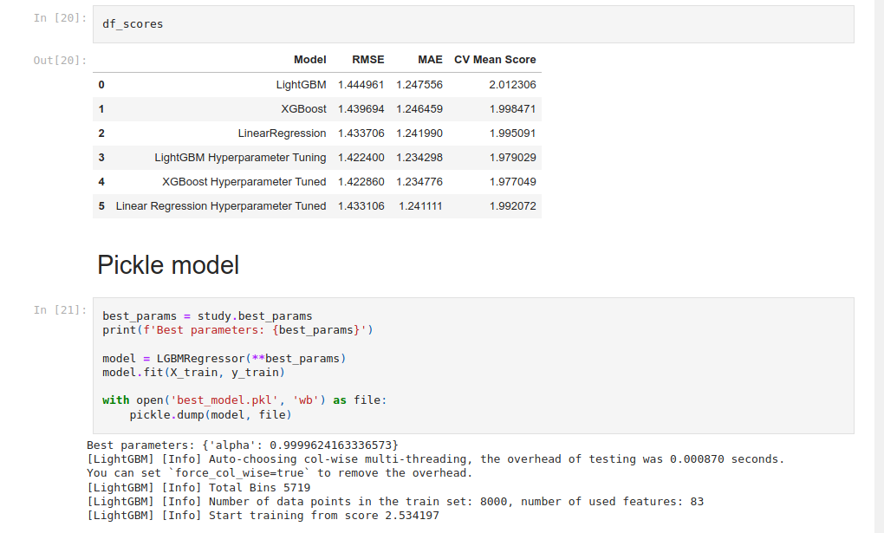

1. Refactor All Codes.

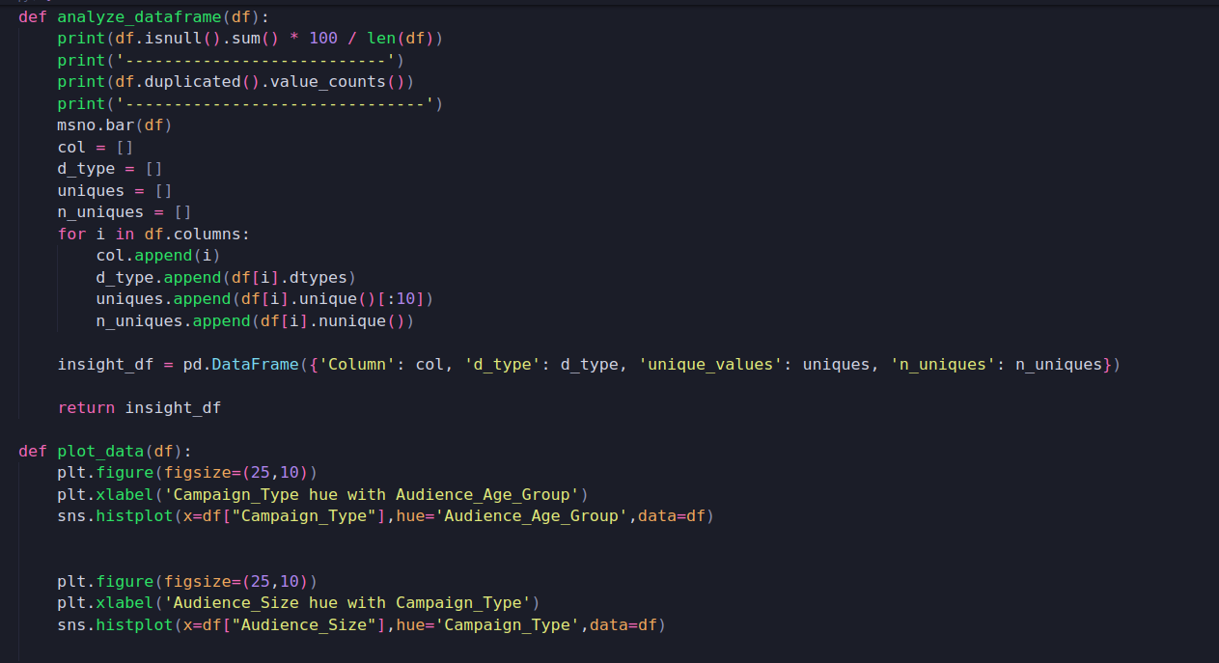

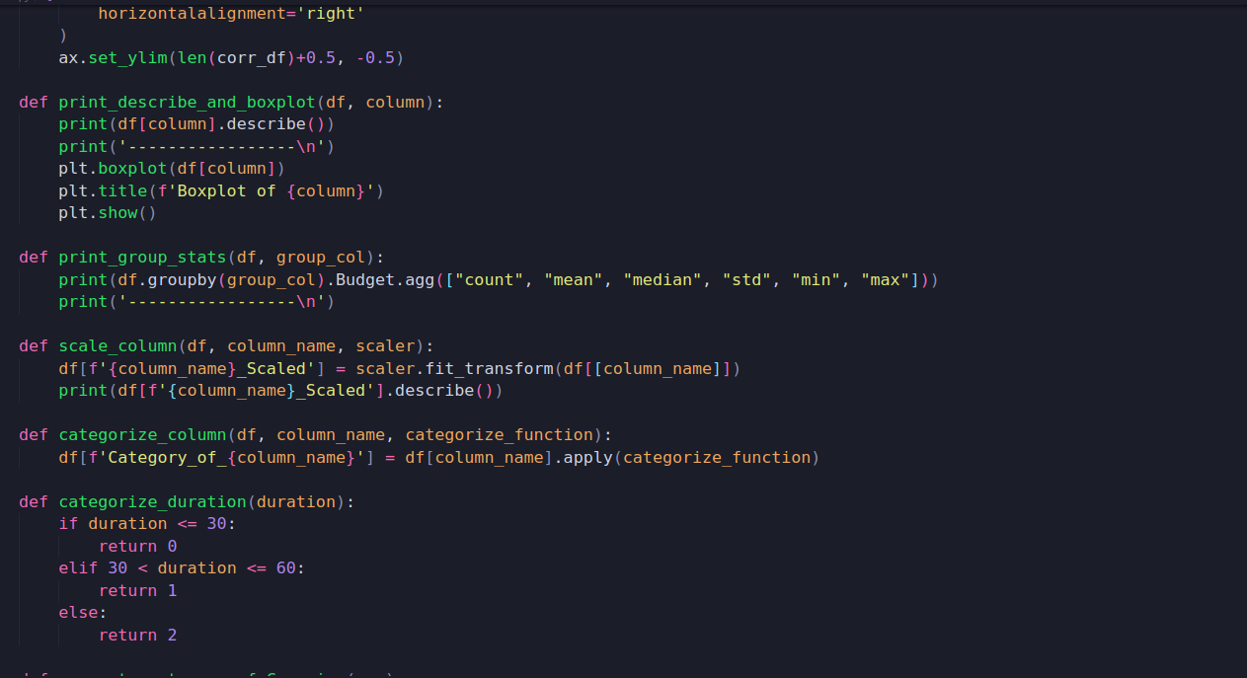

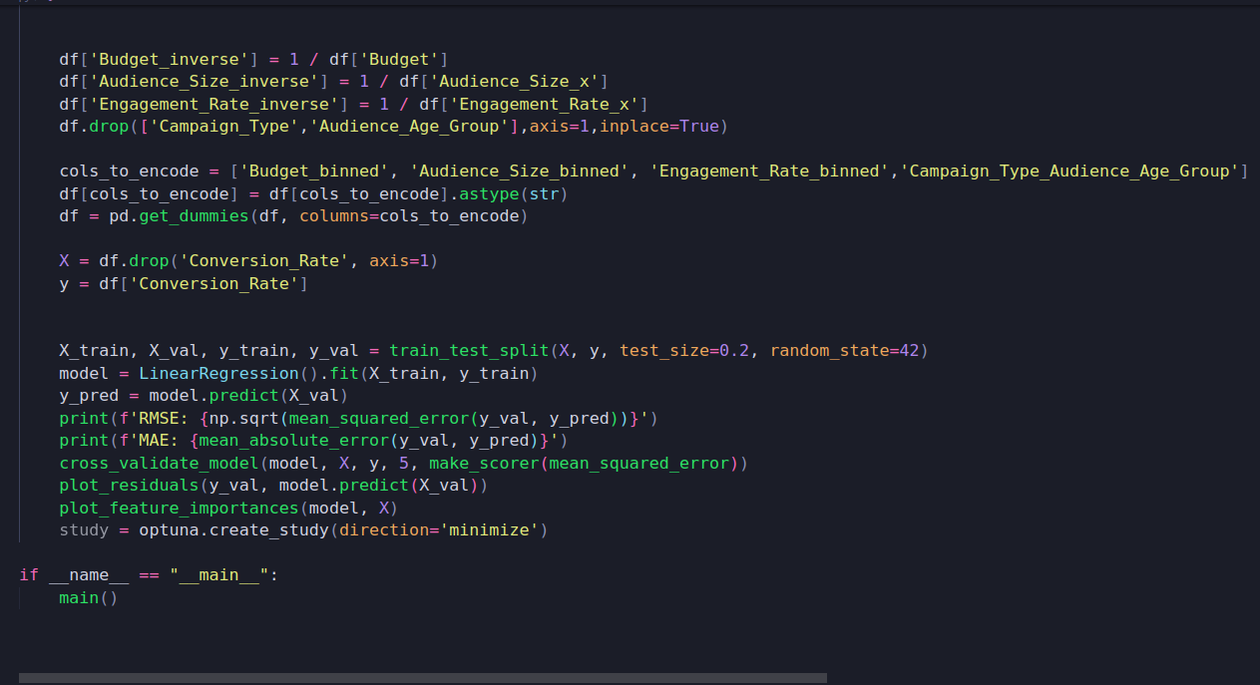

3)Dockerfile

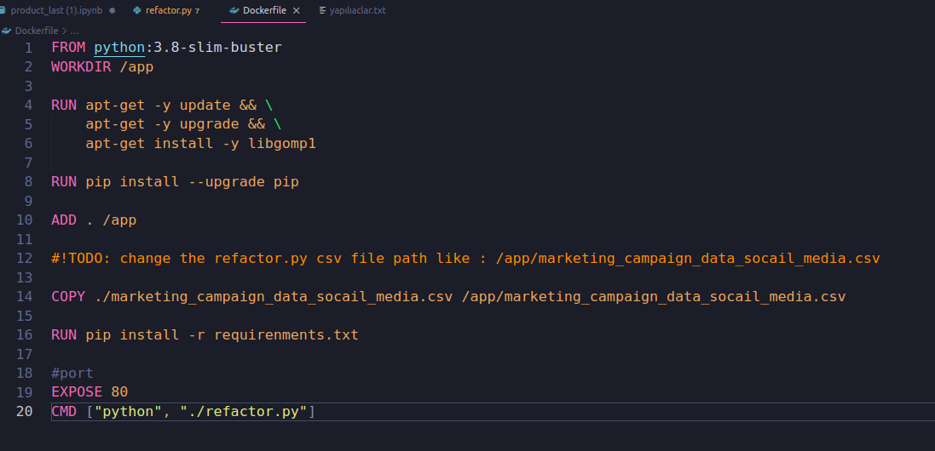

* requirements.txt file

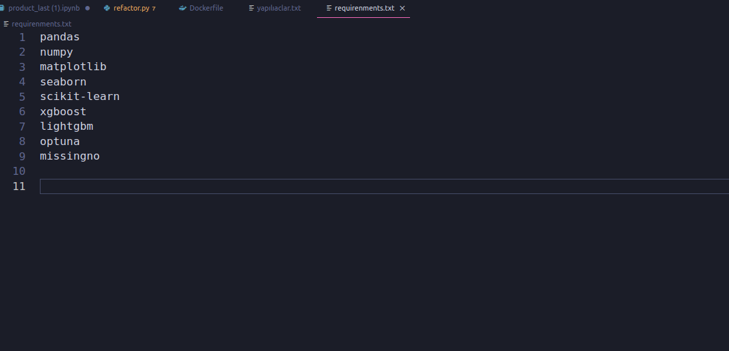

The output of docker file

